# Directions

1. Complete the following programs.
2. Screenshot the running programs. Include enough output to show the program works in its entirety.
3. Submit screenshots/copies of the code.
   1. Partial credit can be had if you made a valiant effort.
4. Submit to Brightspace.

Part 1: Complete Chapter 12 Programming Exercises starting on page 507; provide a snippet of the code and of enough output to show the program works in its entirety.

1. import java.util.Scanner;  
  
public class AddingRecursively {  
 public static void main(String[] args) {  
 Scanner sc = new Scanner(System.*in*);  
 int two =0;  
  
  
 System.*out*.println("Enter the first integer");  
 int one = sc.nextInt();  
  
 do{  
  
 System.*out*.println("Enter the second integer");  
 two = sc.nextInt();  
  
 }while(one>two);  
  
 System.*out*.println(*sum*(one,two));  
 }  
  
 public static int sum(int one, int two)  
 {  
 if(two>one)  
 {  
 return two + *sum*(one,two-1);  
 }  
 else  
 return two;  
 }  
  
}

b. import java.util.Scanner;  
public class AddingRecursively2 {  
 public static void main(String[] args) {  
 Scanner sc = new Scanner(System.*in*);  
 int two =0;  
  
  
 System.*out*.println("Enter the first integer");  
 int one = sc.nextInt();  
  
  
 System.*out*.println("Enter the second integer");  
 two = sc.nextInt();  
  
  
 System.*out*.println(*sum*(one,two));  
 }  
  
 public static int sum(int one, int two)  
 {  
 if(two>one)  
 {  
 return two + *sum*(one,two-1);  
 }  
 else  
 return two;  
 }  
}

3. import java.util.Scanner;  
  
public class SumRangeRecursively {  
 public static void main(String[] args) {  
 int[] nums = new int[20];  
 Scanner sc = new Scanner(System.*in*);  
 int one =0;  
 int two =0;  
  
 do{  
 System.*out*.println("Enter the starting num");  
 one = sc.nextInt();  
 }while(one<0 || one>nums.length);  
  
 do{  
 System.*out*.println("Enter the ending num");  
 two = sc.nextInt();  
 }while(two<=one || two>nums.length);  
  
 for(int x=0;x<nums.length;x++)  
 {  
 nums[x]=x+1;  
 }  
  
// display(one,two,nums);  
 System.*out*.println(*sum*(one,two,nums));  
  
 sc.close();  
 }  
  
 public static int display(int one, int two,int[] nums)  
 {  
 if(one<two)  
 {  
 System.*out*.println(nums[one] + " ");  
 return *display*(++one,two,nums);  
 }  
 else  
 return 0;  
 }  
  
 public static int sum(int one, int two, int[] nums)  
 {  
 if(two>one)  
 return nums[two] + *sum*(one,two-1,nums);  
 else  
 return nums[two];  
 }  
  
  
}

import java.util.Scanner;  
public class VeeRecursive{  
 public static void main(String[] args) {  
 Scanner sc = new Scanner(System.*in*);  
 int before=0;  
  
 System.*out*.println("Enter the amount of lines that you would like to display");  
 int amountLines = sc.nextInt();  
  
 *display*(0,amountLines,before,amountLines);  
 }  
  
 public static String display(int currentLine,int amountLines,int spaceBefore, int spaceBetween)  
 {  
 String before="";  
 String between="";  
  
 for(int x=0;x<spaceBefore;x++)  
 {  
 before+=" ";  
 }  
  
 for(int x=0;x<spaceBetween*2;x++)  
 {  
 between+=" ";  
 }  
  
 if(amountLines>currentLine)  
 {  
 System.*out*.println(before + "V" + between + "V");  
 return *display*(currentLine+1,amountLines,spaceBefore+1,spaceBetween-1);  
 }  
 else  
 return "";  
 }  
}

import java.util.ArrayList;  
import java.util.Scanner;  
  
public class FibDemo {  
 public static void main(String[] args) {  
 Scanner sc = new Scanner(System.*in*);  
 System.*out*.print("Enter a positive ending value: ");  
 int n = sc.nextInt();  
  
 for (int i = 1; i <= n; i++) {  
 System.*out*.print(*fibonacci*(i) + " ");  
 }  
 }  
  
 public static int fibonacci(int n) {  
 if (n == 1 || n == 2) {  
 return 1;  
 } else {  
 return *fibonacci*(n - 1) + *fibonacci*(n - 2);  
 }  
 }  
}

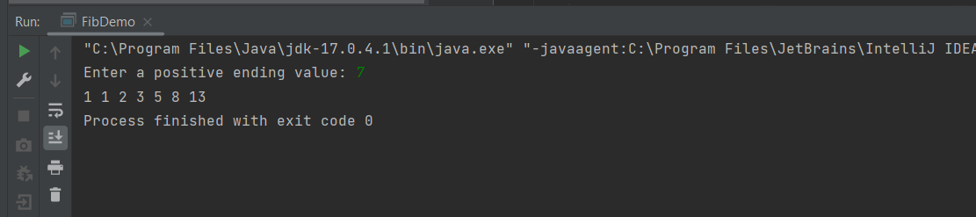

10. import java.util.Scanner;  
  
public class IndirectRecursion {  
 public static void main(String[] args) {  
 Scanner sc = new Scanner(System.*in*);  
  
 System.*out*.println("Enter the num");  
 int num =sc.nextInt();  
  
 *method1*(num);  
 }  
  
 public static int method1(int num)  
 {  
 if(num>0) {  
 System.*out*.println(num);  
 return *method2*(num - 1);  
 }  
 else  
 return num;  
 }  
  
 public static int method2(int num) {  
 if(num>0) {  
 System.*out*.println(num);  
 return *method1*(num);  
 }  
 else  
 return num;  
 }  
}

Part 2: Pick one of the Game Zone on Pg. 509. Provide a snippet of your code and a snippet of the output:

import java.util.Scanner;  
  
public class Disk {  
 public static void main(String[] args) {  
 Scanner sc = new Scanner(System.*in*);  
 System.*out*.println("Enter the number of disks");  
 int disks = sc.nextInt();  
 *move*(disks, 1, 3, 2);  
 }  
  
 public static void move(int disks, int start, int end, int middle) {  
 if (disks == 1) {  
 System.*out*.println("Move " + start + " to " + end);  
 } else {  
 *move*(disks - 1, start, middle, end);  
 System.*out*.println("Move " + start + " to " + end);  
 *move*(disks - 1, middle, end, start);  
 }  
 }  
}

